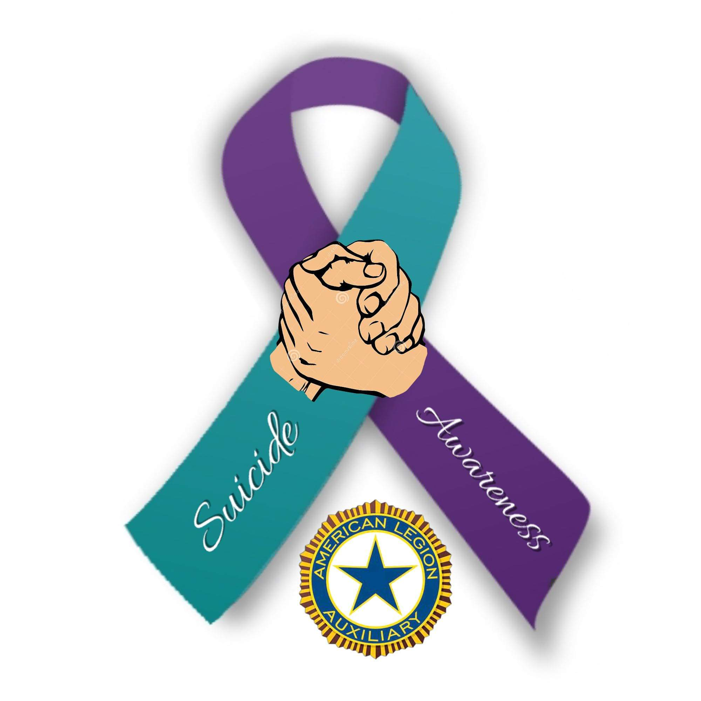
American Legion Auxiliary, Department of Maine Veteran Suicide Awareness and Prevention
2022—2023 Department President’s Project
YOU WILL NEVER WALK ALONE
Individual (or) Organization Name:
Current statistics show that 17 veterans are dying a day from suicide. I plan to walk a minimum of 17 miles, one mile for each veteran we lose every day, for the American Legion Auxiliary “You Will Never Walk Alone” walk-a-thon.
Dear Potential Sponsor,
I am participating in this important Walk-A-Thon. All proceeds will help fund Veterans Suicide Prevention and Awareness. You can sponsor me for an amount per mile and can name a maximum amount that you are willing to contribute. After the event, I will return to tell you how many miles I walked and collect your contribution. Make checks out to Maine ALA.
Thank you!
Name of Sponsor |  | Pledge per Mile (Example: $5.00) | Maximum Pledge | Amount Collected from Sponsor | Sponsor Phone/  E-mail
1
2
3
4
5
6
7
8
9
10
11
12
13
14
15
16
17

American Legion Auxiliary, Department of Maine
YOU WILL NEVER WALK ALONE WALK-A-THON

The goal of this walk-a-thon is to raise needed funds to help spread awareness and prevention of veteran suicide through collaboration with the Veterans Suicide Prevention Coordinator at the Togus VA Medical Center.
We hope that individuals, Units, Squadrons, Posts, Riders Chapters will participate.

Rules
- Participants may start collecting pledges as soon as they receive the pledge sheets, June 12, 2022.
- Miles do not have to be walked all in one day. You may track your miles from June 12, 2022 – April 15, 2023.
- All pledge sheets and moneys are due back to the Maine American Legion Auxiliary by May 1, 2023.
- Pledges may be made by anyone. Each sponsor making a pledge should write their own name, pledge per mile and maximum pledge. Participants may collect the pledge in advance but must keep pledges until all are collected.
- Walkers are encouraged to reach out not only to friends and families, but businesses and/or organizations for sponsorships as well.
- Auxiliary members are encouraged to involve your juniors, Legion Post, SAL Squadron members as well. Consider having several members walk together and make it an event.
- Participants may walk anywhere … indoors, outdoors, etc. Get your local high school, community center, etc. involved to see if you can use their track.
- On the days participants walk, show your pride of being a member by dressing branded; carrying an American Flag; dressing patriotically. Make it fun while staying fit!
- Please share lots of pictures when you’re walking on our Facebook group: American Legion Auxiliary, Department of Maine.
Please return pledge sheets with the money, made payable to:
Maine American Legion Auxiliary
5 Verti Drive, Suite B
Winslow, ME 04901
By May 1, 2023
We look forward to all our participants having a great time!
Any questions, contact Debra Rumery at debrarumery@gmail.com

