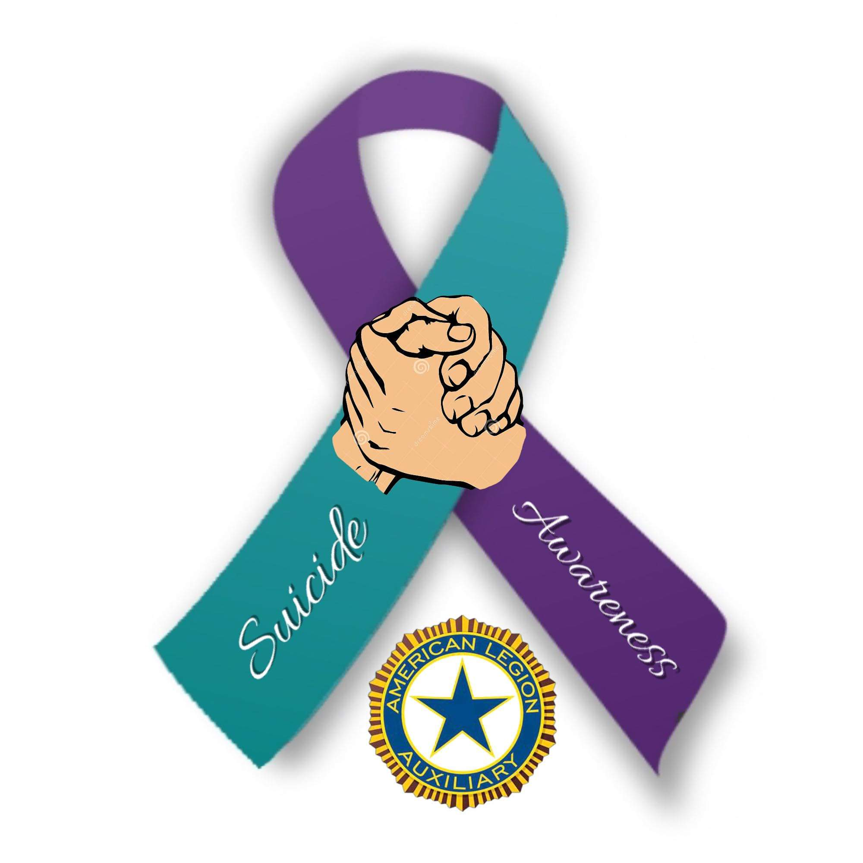
Veteran Suicide Awareness and Prevention
2022—2023 Department President’s Project

YOU WILL NEVER WALK ALONE

In 2022 it is estimated that 17 veterans commit suicide on a daily basis.

How do we help?

Togus VA Unit 63 is home to some of Maine’s vulnerable veterans. There are a multitude of ideas and needed items your donations can help with for Unit 63. We are not asking for items to be donated, only monetary donations to purchase items requested by Togus as the needs change on a regular basis.

Ideas for Unit 63
Stationary items Slippers
Greeting cards (use 200-300 per month) Puzzles
Toiletries (full-size) DVDs
Paperback books Games
Possible creation of a library on Unit 63 Sensory items
Christmas gifts for residents Therapeutic fish tank
Sponsor events, such as pizza parties; movie nights Bait/tackle boxes
Drawing pads (non-spiral bound)
Nintendo Switches w/extra controllers

Additionally, when patients are discharged they are given resource bags and some receive clothing and shoes. Donations can help purchase items to go into the resource bags, such as sunscreen, bandages, informational pamphlets and other basic necessities.

We will also be working with VA Maine Suicide Prevention Program and Outreach at Togus.

This office works with veterans on Unit 63, but they also have a massive community outreach working with local police, NAMI, DHHS, CBOCs and other agencies working on suicide prevention statewide.

Your donations can assist with creating resource kits that are distributed statewide to help in prevention efforts.

Start your plans today to hold a fundraiser

for this much needed project for our veterans.

We’re kicking off fundraising efforts with the idea of holding walk-a-thons; please see the walk-a-thon flyer for further information. However, that is only one idea of how to raise funds. Be creative as you always are.

Send all donations to Maine ALA, earmarked “President’s Project” to Maine ALA, 5 Verti Drive, Suite B, Winslow, ME 04901.

SUICIDE PREVENTION IS EVERYBODY’S BUSINESS

